TITLE OF THE PAPER

SURNAME First name¹, SURNAME First name², SURNAME First name³

^{1, 3} University, Faculty, Department, Postal address, 123456, City, Country, E-Mail:

² University, Faculty, Department, Postal address, 123456, City, Country, E-Mail:

Corresponding author: Surname, First Name, E-mail:

Abstract: These instructions give you guidelines for preparing camera – ready papers for the Journal “Annals of the University of Oradea. Fascicle of Textiles, Leatherwork”. Papers should be submitted in camera–ready form on 4 (four) or 6 (six) A4 page. Please do not submit papers with more than six or less than four A4 pages. The manuscript will be reproduced full size from your copy. So, please write your paper directly in this template. The abstract portion is a narrative presentation without references, and should have 200-250 words.

Key words: List 5-6 keywords. Key words should not repeat the title of the paper.

- Introduction

Please write different author’s affiliations only for different affiliations (do not repeat the same affiliation) and write them respecting the format recommendations (capitals or not, respectively), including the order of SURNAME and First name.

2. GENERAL information

2.1 Layout
Please prepare your camera–ready paper in full–size format, on A4 paper (29.7 cm x 21 cm). Papers should comprise 4 (four) or 6 (six) A4 pages and should be sent (both the Word and the PDF files) by e-mail or through the Conference websites, using the provided submission instructions. Please do not submit papers with more than 6 or less than 4 A4 pages.
We request you to please quote in your paper one of the articles published in the previous editions of our journal "Annals of the University of Oradea. Fascicle of Textiles, Leatherwork."
Kindly find below the link for the articles: http://textile.webhost.uoradea.ro/Annals/Volumes.html
Margins: top, bottom-15 mm each, right and left -25 mm each. The paper should be written in plain English.
Please use Times New Roman fonts, line spacing single.
The font formats are:

Table 1: Type sizes for camera-ready papers
Type size | Use for
10 | Table captions, author’s affiliations, keywords, references, tables, figure captions
11 | Main text, Equations, Section subtitles, subheadings
12 | Author names, Chapter titles
14 | PAPER TITLE

3. FIGURES AND TABLES

3.1. Figures
The figures have to be made in high quality, which is suitable for reproduction and print. Please don't include the colour photos.
Figure captions should be below the figures, centered. Use the abbreviation Fig. 1 even at the beginning of a sentence.

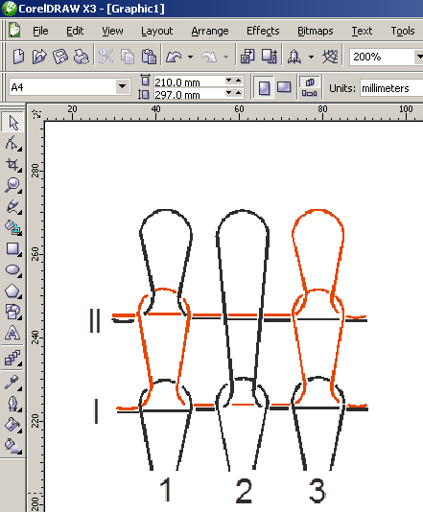
Fig. 1: Irregular jacquard

3.2. Tables
Each table is numbered and table captions are in TNR 10 pt, placed above the table.

4. EQUATIONS

Equations are left justified 5 mm from left with equation number at the right margin in font TNR 11 pt Italic.
$R_{a}=\text{ 0,65}⋅R_{\text{max}}^{0,9}$ (1)

5. ConclusionS

Summarize the conclusions of the paper in a simple, straightforward way. Emphasize the original contribution of the authors.
Please read carefully these instructions for authors. Papers delivered in incorrect form, will not be published in the proceedings.
For the paper to be published it is necessary to send it in electronic form by e-mail:
- For the section Textiles- liliindrie@yahoo.com
- For the section Leather and Leather substitutes- sgherghel@uoradea.ro
- For the section Management and Marketing - tripasimona@yahoo.com

ACKNOWLEDGEMENTS

Eventually – information about sponsors etc.

References

Citations in text should be made with Arab numerals in square brackets [1], [2], [3]. References should be presented in consecutive order (as they are referred to in the text) at the end of the paper, after one clear line in NTR 11 pts [4]. Please include at least 6 items [5]. References will be given in the original language [6]. Publications by the same author(s) should be listed in order of year of publication [7].Please take into consideration that all references listed here is compulsory to be directly cited in the body of the text [8]. Please don’t use the own quotations.

[1] G. O. Young, “Synthetic structure of industrial plastics”, in Plastics, 2nd ed., vol. 3, J. Peters, Ed. New York: McGraw-Hill, 1964, pp. 15–64.
[2] J. U. Duncombe, “Infrared navigation—Part I: An assessment of feasibility,” IEEE Trans. Electron Devices, vol. ED-11, pp. 34–39, Jan. 1959.
[3] E. P. Wigner, “Theory of traveling-wave optical laser,” Phys. Rev., vol. 134, pp. A635–A646, Dec. 1965.
[4] D. B. Payne and J. R. Stern, “Wavelength-switched passively coupled single-mode optical network,” in Proc. IOOC-ECOC, 1985, pp. 585–590.
[5] D. Ebehard and E. Voges, “Digital single sideband detection for interferometric sensors”, presented at the 2nd Int. Conf. Optical Fiber Sensors, Stuttgart, Germany, 1984.
[6] E. E. Reber, R. L. Mitchell, and C. J. Carter, “Oxygen absorption in the Earth’s atmosphere,” Aerospace Corp., Los Angeles, CA, Tech. Rep. TR-0200 (4230-46)-3, Nov. 1968.
[7] J. Jones. (1991, May 10). Networks. (2nd ed.) [Online]. Available: http://www.atm.com
[8] R. J. Vidmar. (1992, Aug.). On the use of atmospheric plasmas as electromagnetic reflectors. IEEE Trans. Plasma Sci. [Online]. 21(3), pp. 876–880. Available: http://www.halcyon.com/pub/journals/21ps03-vidmar

